**US 005-TC 005_005: Verify the working of "CONTINUE SHOPPING" button in cart page**

Step 1: Navigate to swag labs site

Step 2: Login as "standard_user" into the website

Step 3: Click on the cart icon

Step 5: Click on "continue shopping" button in cart page.

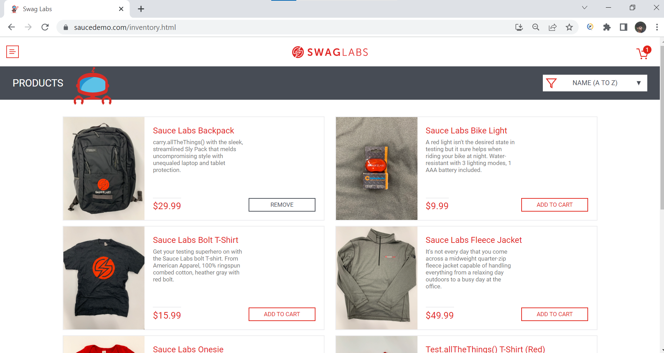

**User is able to** **navigate back to Home page.**

**Test case Passed.**